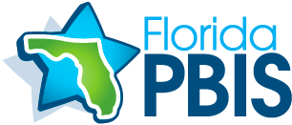

**PBIS News** December 2019

Our Positive Behavioral Interventions and Support (PBIS) team meets each month to discuss trends in discipline reports, share strategies, and create school-wide incentives and programs to support our students as they learn. But even when we aren’t actively talking about and thinking about PBIS we are ALL using positive reinforcements every day. Here is a sample of the great things happening at our school:

* Teachers notice and praise positive behaviors.
* Students encourage each other to be productive.
* Students recite the Hawks Rise Promise every day.
* Our positive behavioral expectations are posted all around the school.
* Students take pride in knowing and practicing our Hawks Rise Expectations.
* Everyone is encouraged to contribute positively to our school community.

At Hawks Rise, supporting positive behaviors includes respecting students as individuals, promoting increased social belonging, and teaching students how to achieve desired outcomes. Students may not understand these big concepts, but they do understand that learning in an uplifting and supportive environment is more fun. Looking for the positive helps us all become more productive and successful!